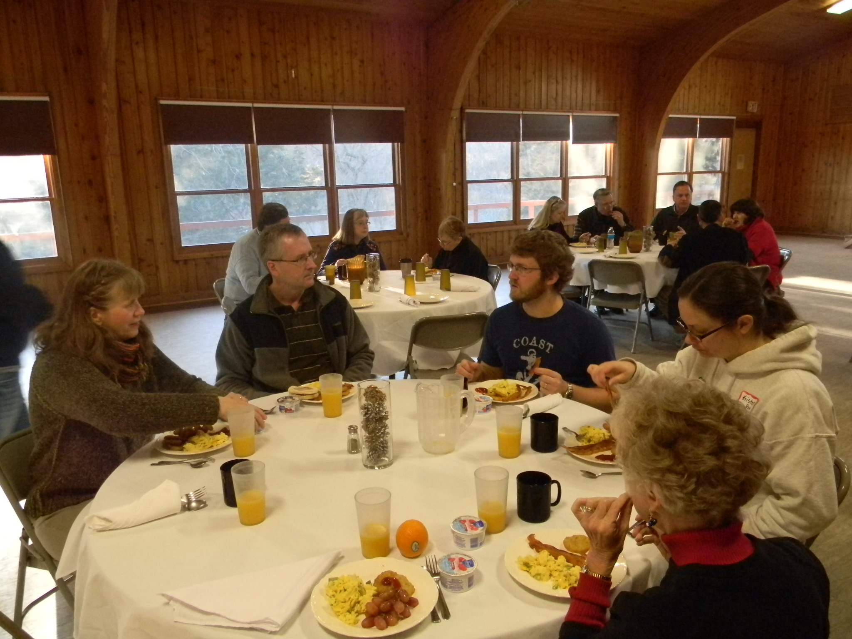  Adult Enrichment Retreat Day  We’re excited to welcome Dr. Mark Yackel-Juleen as our Adult Enrichment Day speaker this fall. Adults, come and spend a day at Camp Ewalu and learn about the current state of rural ministry. Enjoy a morning of coffee and fellowship at Ewalu’s beautiful main site.  Come at 9:00 a.m. for coffee and rolls in the Creation Center chapel. Dr. Yackel-Juleen will start his presentation shortly after. A free-will lunch will be served at 12:00 p.m. in Cedar Lodge.  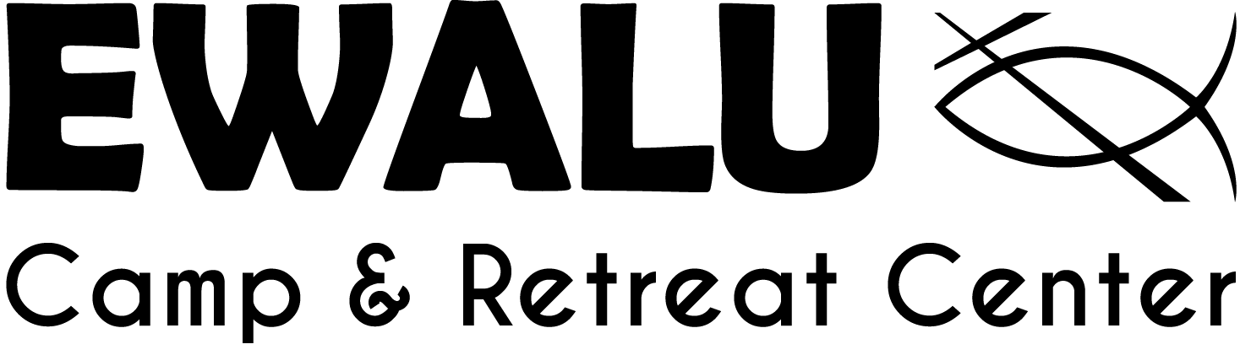 | October 18th 9:00 a.m. - 1:00 p.m.  Learn about rural ministry with Wartburg Seminary Professor Dr. Yackel-Juleen  Join us for coffee, fellowship, and a freewill Lunch  To Sign Up: Call Diane at (563)-933-4700  Ewalu Camp and retreat center  37776 Alpha Ave, Strawberry Point, IA 52076  563-933-4700  www.ewalu.org  http://ewalu.org/event/adult-enrichment-retreat-day/

