DIRTY FEET RETREAT

October 1–3, 2021

Friday

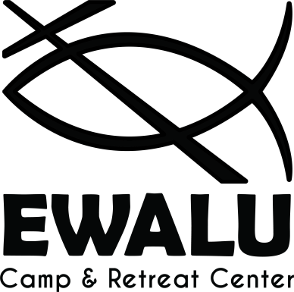
8-8:30 Arrive, Check-in Creation Ctr.
Games Cedar Lodge
9:00 Adult Leader Meeting
9:15 Welcome & Opening
9:45 Faith Conversation #1
10:30 Snack
11:00 Omega Cabins

Saturday

8:00 Breakfast
9:00 Alpha Morning Devotions
9:45 Faith Conversation #2
10:30 Youth Worship Planning
Practice for Variety Show / Free time
12:00 Lunch
12:45 Rotations (3x70m) Zip Line / Cooperative Course /
Games & Nature Hike
4:30 Large Group Game
6:00 Supper
6:45 Free Time & Prep Cabins
7:30 Variety Show Cedar Lodge
8:45 Campfire Central Plains Fire Ring
10:00 Omega Cabins

Sunday

7:15 Rise & Shine
8:00 Breakfast
Wake Up, Pack-up, Clean-up
10:00 Worship
11:00 Go in Peace, Serve the Lord!

