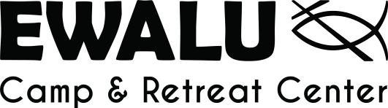

Welcome to Pack and Paddle!

Dear Parents/Guardians and Pack and Paddlers,

As a part of your Pack and Paddle experience, your group will participate in two adventures during the week. The first half will be spent backpacking to nearby Backbone State Park and includes climbing on natural rock faces. Climbing will be led by a qualified facilitator on the Camp Ewalu staff that has been certified by a professional ropes course company. (A release form attached at the end of this document is required for this activity.) Additionally, the second half of the week will be filled with canoeing down the Turkey River and camping along the way.

The general packing list will get you through the week, though we would like to highlight a few specific items. Please be sure to have sturdy, broken-in hiking shoes or boots, as the backpacking portion covers around 8 miles of trails. A 32 oz. water bottle, such as a Nalgene, is recommended as time between filling water can be extensive. We suggest a sturdy pair of water shoes for the canoeing potion. Flip-flops and slides will not fare well.

During the week, Camp Ewalu staff will aid campers to pack necessary items into provided bags for each half of the week. All unused gear will be stored for campers while they are off-site. Ewalu provides both frame packs for the hiking trip and dry bags for the canoeing trip, though campers are welcome to bring their own should they have either.

Please be sure to fill out the release form and bring it with you to when you arrive on Sunday. If you have any questions or concerns, please feel free to contact Ewalu.

Sincerely,

Ashley Gulrud
Interim Program Director
563-933-4700
camp@ewalu.org

Rock Climbing Release Form: Pack and Paddle
Camper Name: Birth Date: Gender:
Address: Phone:
Legal Guardian: Work Phone:
(Parent / legal guardian of camper if under 18 years of age)

RELEASE: I give permission for my child to participate in rock climbing at Backbone State Park. I understand that even with precautions, there are hazards associated with rock climbing. I agree that Camp Ewalu, its staff, the Department of Natural Resources, and the State of Iowa will not be held responsible for accidents or personal injury arising from my child’s participation in rock climbing. Furthermore, I affirm the health and physical abilities of my child to be sufficient for activities such as rock climbing. I also authorize the Executive Director, Environmental Education Director, Program Director, Health Officer, and medical personnel selected by the staff of Ewalu or of Backbone State Park to secure any medical or emergency treatment deemed necessary. I understand my insurance is primary for my child in case of an accident or emergency. I declare that all statements on this form are true.

PARENT/GUARDIAN SIGNATURE: _________________________________ DATE: ___________

