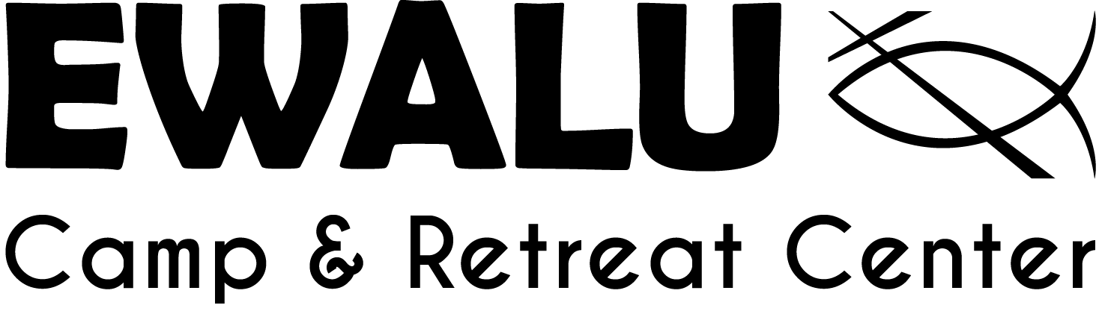

FAMILY CAMP INFORMATION

REGISTRATION AND PICK-UP: Arrival and registration is from 5:30 to 6:00 p.m. Friday at the Creation Center.
We conclude at 11:00 a.m. Sunday.

CAMP LOCATION: Ewalu’s Main Site is located at 37776 Alpha Ave., about three miles west of Strawberry Point, Iowa, along Iowa Highway 3. A green road sign marks “Camp Ewalu – Main Site.” From Highway 3, turn south on Alpha Avenue, and go one mile south.

LODGING: Choose lodging in one of our cabins or camp in the Family Campground. Cabins are available on a first-come, first-served basis. A discount is provided if you choose to stay in the campground.

INSURANCE: In the event of an accident or injury, the insurance of the camper’s legal guardian(s) is primary.

LOST AND FOUND: Lost & Found items are kept for a short time following your visit. Ewalu is not responsible for lost or broken items. Please contact camp as soon as possible to report a missing item. After a month, unclaimed items will be discarded or donated to a local charity. Remember to label all clothing and valuables.

PAYMENT: A $100 deposit is due upon registration. Full payment is due three weeks prior to arrival.

SUMMER THEME: Our 2023 summer curriculum is “Holy Trinity Wholly Love.” Wading into the mystery of the Holy Trinity can be a daunting endeavor. But that is precisely what we are going to do this summer. Daily themes include: Who is God the creator? Who is Jesus? Who is the Holy Spirit? Who am I? Who are We? Ewalu programs help kids develop greater leadership skills, positive social skills, and personal confidence.

OUR STAFF: The Ewalu summer ministry staff will be living, sharing, playing, and praying together with your family. Our team is selected for their genuine love for kids, active faith in God, and desire to share their Christian faith and joy. They are here to help all campers grow personally and spiritually. We are excited and privileged to offer a unique, worthwhile, safe and fun experience for campers, with a lasting positive impact!

Packing List: Label belongings with camper’s name.

- T-shirts & shorts
- Socks & underwear
- Long sleeves & pants for nights/cool weather
- Pajamas
- Beach towel & swimming suit
- A hat to protect from the sun
- Face masks (optional)
- Toiletries (toothbrush, toothpaste, soap, etc.)
- Bible
- Water bottle
- Flashlight
- Backpack/bag for water bottle & swim items
- Sunscreen & insect repellent
- Raincoat/poncho

- Prescribed medication
- Spending money for the Canteen (snack shop) and camp store
- TWO pairs of closed-toed shoes (tennis shoes and shoes that can get wet; NO flip-flops on trails)

What NOT to Bring: Please do not bring valuables, pets, drugs (nicotine, alcohol, etc.), weapons, and phones or other electronic devices. Adults may keep phones for emergencies or for picture taking, but we encourage you to refrain from using them in an effort to retreat and to limit distractions.

Questions? Call Ewalu (563-933-4700) or email camp@ewalu.org.

Tentative 2023 Family Camp Schedule

Friday
5:30-6 pm Check-in at Creation Center
6:00 pm Official Welcome with Dinner - Cedar
7:30 pm Walk to Opening Campfire - Cedar (Bring warm clothes, bug spray, flashlights, etc.)
7:45 pm Campfire at Central Plains
8:45 pm Cabin time & Omega/Optional Night Swim

Saturday
8:00 am Breakfast at Cedar Lodge
9:00 am Alpha at Outdoor Chapel
10:00 am Bible Study (by age groups)
11:00 am Family Activity
11:00 am Guided Nature Hike
12:00 pm Lunch at Cedar Lodge
1-5 pm Exploration Stations (Sign up in Cedar Lodge)
- Free Time - explore, play, or relax
- Zip Line
- Swimming Pool
- Tractor Rides to Farm
- Crafts
- Self-Guided Nature Activities
5:30 pm Picnic Supper on Cedar Lodge Pavilion
7:00 pm Campfire at Barred Owl Lodge
8:30 pm Cabin Time & Omega/Optional Night Swim

Sunday
8:00 am Breakfast at Cedar Lodge
10:00 am Worship in Creation Center Chapel
11:00 am Go in peace to love and serve the Lord!

